Assignment 3 (sorting research)
To get a better understanding of how the big o influences the speed of the sorting process, I settled on picking 3 sorting algorithms which are drastically different. The three different sorting processes all make use of the big O, but one in an efficient way then the other.

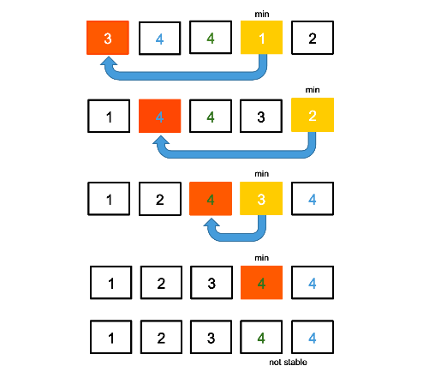
Selection Sort ( Best/Worst : O(n^2) )
Figure 1 : selection sort.
The sorting process, selection sort, is a one of the simplest forms. This way of sorting is not as efficient regarding to larger lists since it continuously goes over the list and repositions the smallest number until each element is sorted. Besides that this way of sorting is not as reliable.
The reason for picking this sorting technique, is because it is a slow process in comparison with others.

Bubble Sort ( Best : O(N), Worst : O(N^2) )
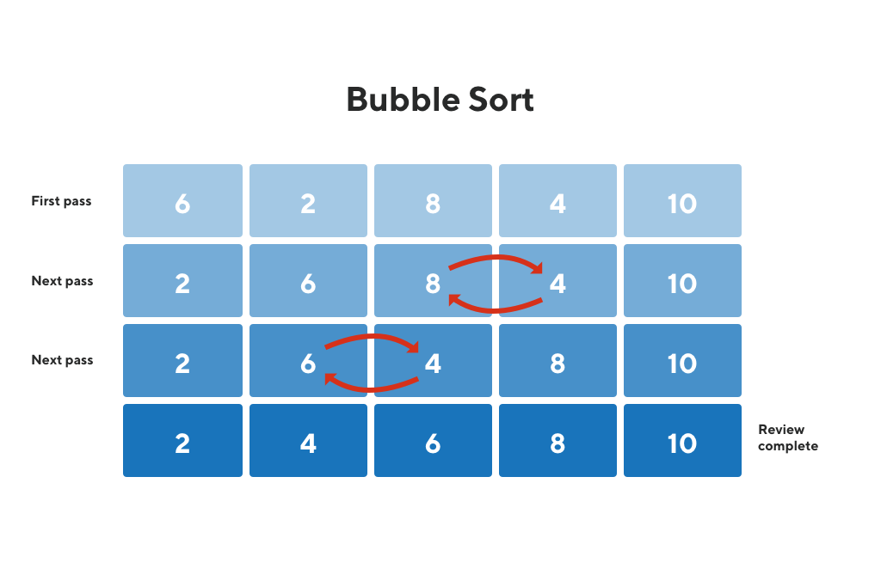
The sorting process, counting sort, is more efficient way of sorting. Even thought it is an more efficient wat of sorting in comparison with selection sort, it will become a slower process when the lists become too large. Besides that this way of sorting is not very stable since the best and worst cases are far apart, meaning that you will never be certain about how fast the sorting process will be.
Figure 2 : bubble sort.
The reason for picking this sorting technique is since it has the possibility to preform drastically better then selection sort.

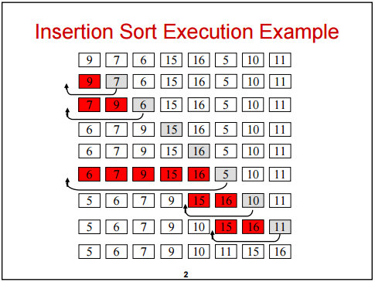
Insertion Sort ( Best : O(N), Worst : O(N^2) )
Figure 3 : insertion sort.
The sorting process, insertion sort, is just like the bubble sort a more reliable way of sorting. It doesn’t have to run trough the list multiple times before the sorted list is created. It passes trough the list and makes use of insertion.
The reason for picking the insertion sort as my final choice has to do with the method of sorting. The previous two methods made use of either exchanging or selection, and insertion makes use of a different one, insertion.

Conclusion
Each of these three sorting systems have their own way of being reliable and/or convenient. Regarding to the performance times which are displayed in the Figure 4 and Figure 5 , there can be seen that in the second and third algorithm there is less of a stability in its performance time. Where the first algorithm, the selection sort, displays a smaller range in between its performance time. Regarding to the second, bubble sort, and the third, insertion sort, there is a bigger difference in between its results. This can be explained with the help of the Big-O complexity chart. These sorting algorithms are less reliable regarding to its performance due to the wider range in the Big-O chart.
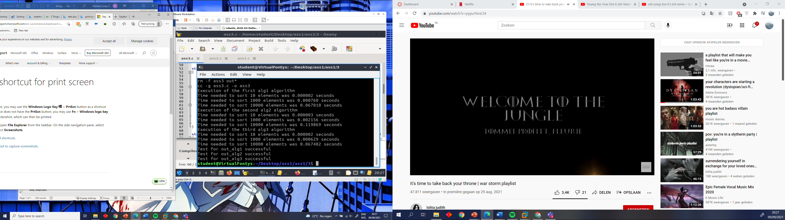
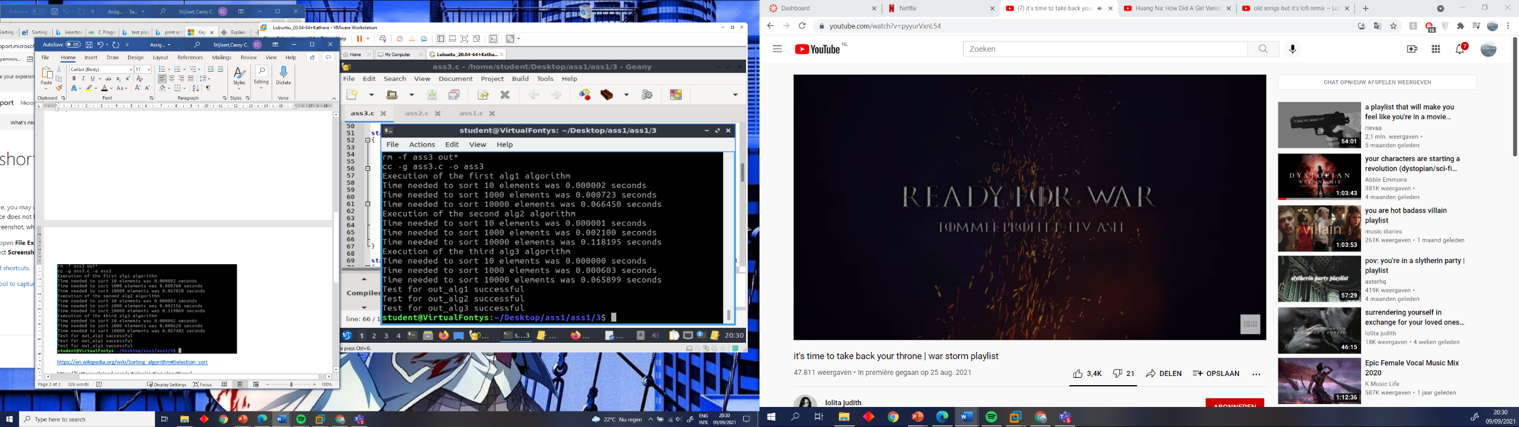
Therefor it is from great importance to research which sorting algorithm suits the purpose it’s best, since there might me a huge chance that the results are compromised.
Figure 4 : make test 1.
Figure 5 : make test 2.

References
bubble sort. (n.d.). From geeksforgeeks: https://www.geeksforgeeks.org/bubble-sort/
insertion sort. (n.d.). From khanacademy: https://www.khanacademy.org/computing/computer-science/algorithms/insertion-sort/a/insertion-sort
Selection Sort. (n.d.). From wikipedia: https://en.wikipedia.org/wiki/Sorting_algorithm#Selection_sort
sorting algorithms. (n.d.). From betterexplained: https://betterexplained.com/articles/sorting-algorithms/
sorting algorithms. (n.d.). From tutorialspoint: https://www.tutorialspoint.com/data_structures_algorithms/sorting_algorithms.htm

